**Proxy**

**General UML diagram for proxy design pattern:**

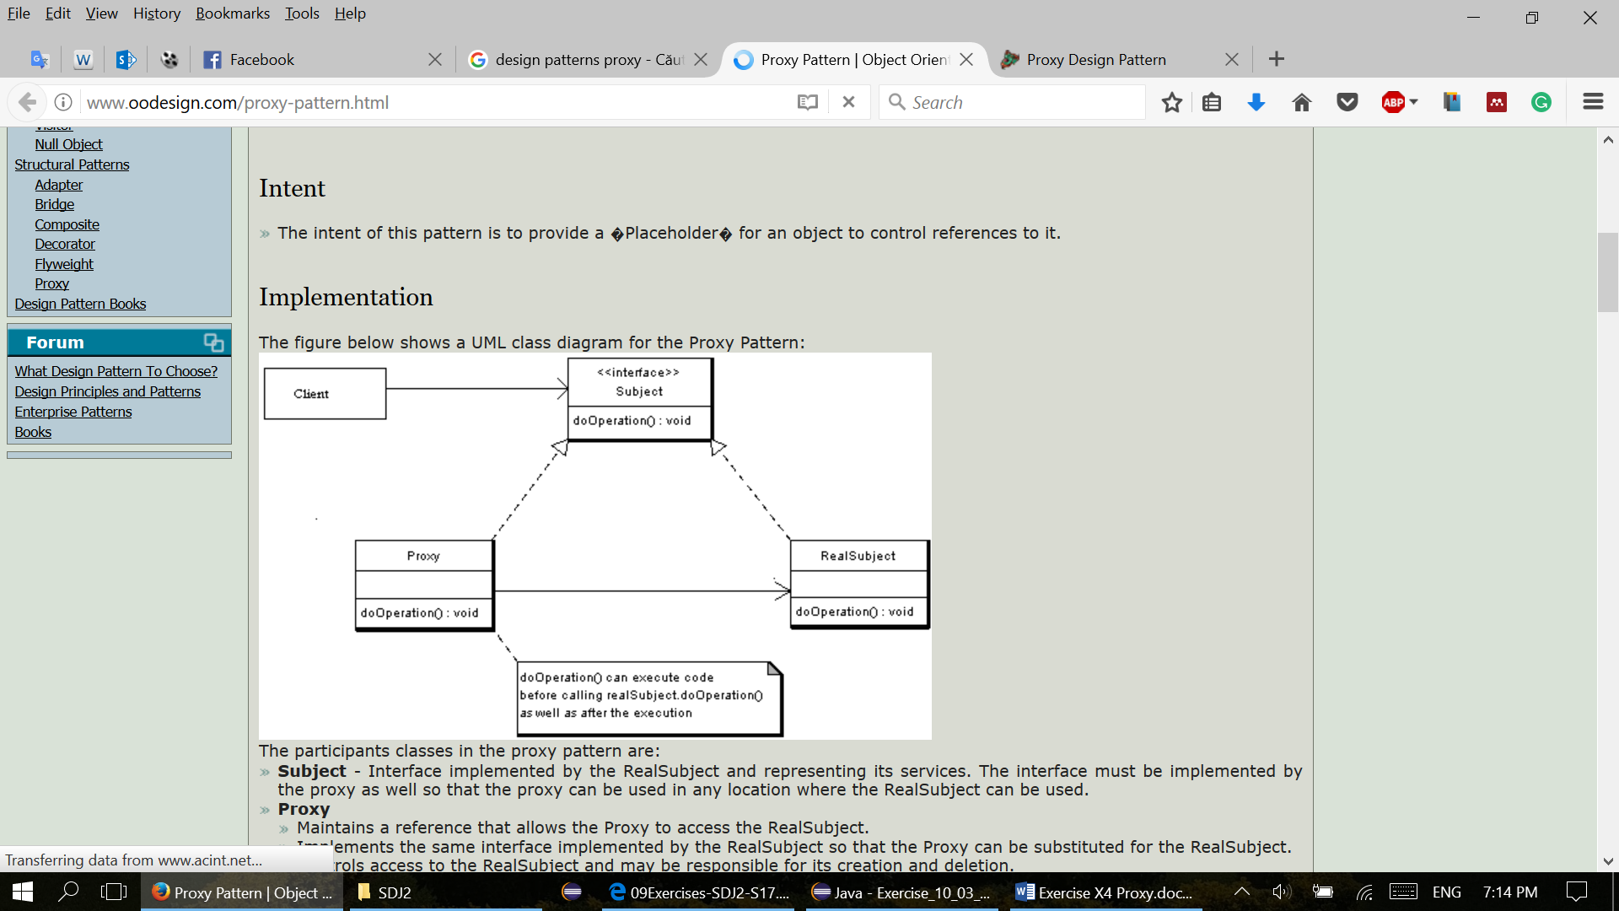

**Overall purpose for proxy design pattern:**

* Proxy provides a placeholder for another object to control access to it. A wrapper to delegate work to a real subject.
* It can be a thread safe collection delegating work to another collection in synchronized methods, or a client object with access to a model on another computer.

**General UML diagram description:**

* The Subject is interface implemented by the RealSubject, representing its services. The interface must be implemented by the proxy as well, so that the proxy can be used in any location where the RealSubject is used.
* The proxy has an instance variable from RealSubject that allows the Proxy to access it. Implements the same interface implemented by the RealSubject, so that the Proxy can be substituted for the RealSubject. Controls access to the RealSubject and may be responsible for its creation and deletion.
* RealSubject is the real object that the proxy represents.

**Usage of proxy design pattern:**

* A client obtains a reference to a Proxy, then the client handles the proxy in the same way it handles RealSubject and therefor invoking the method doSomething(). At that point the proxy can do different things prior to invoking RealSubject - doSomething() method. The client might create a RealSubject object at that point, perform initialization, check permissions of the client to invoke the method, and then invoke the method on the object. The client can also do additional tasks after invoking the doSomething() method, such as incrementing the number of references to the object.

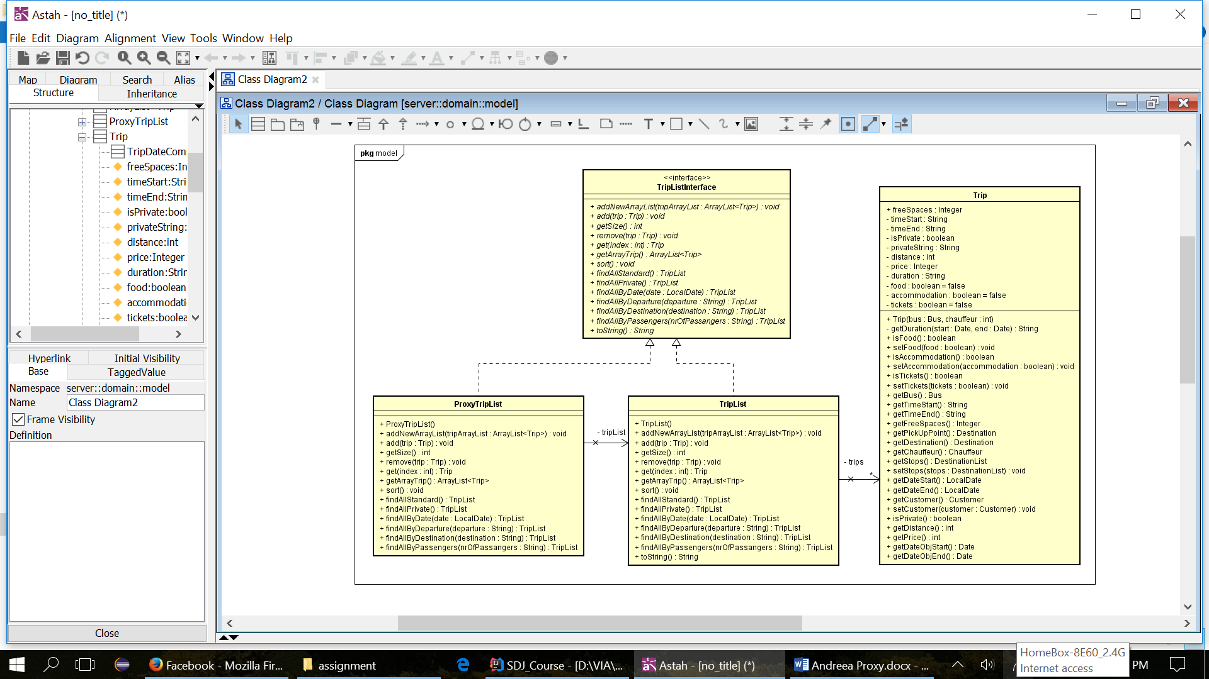**Our implementation:**

**Code examples:**

* Proxy class

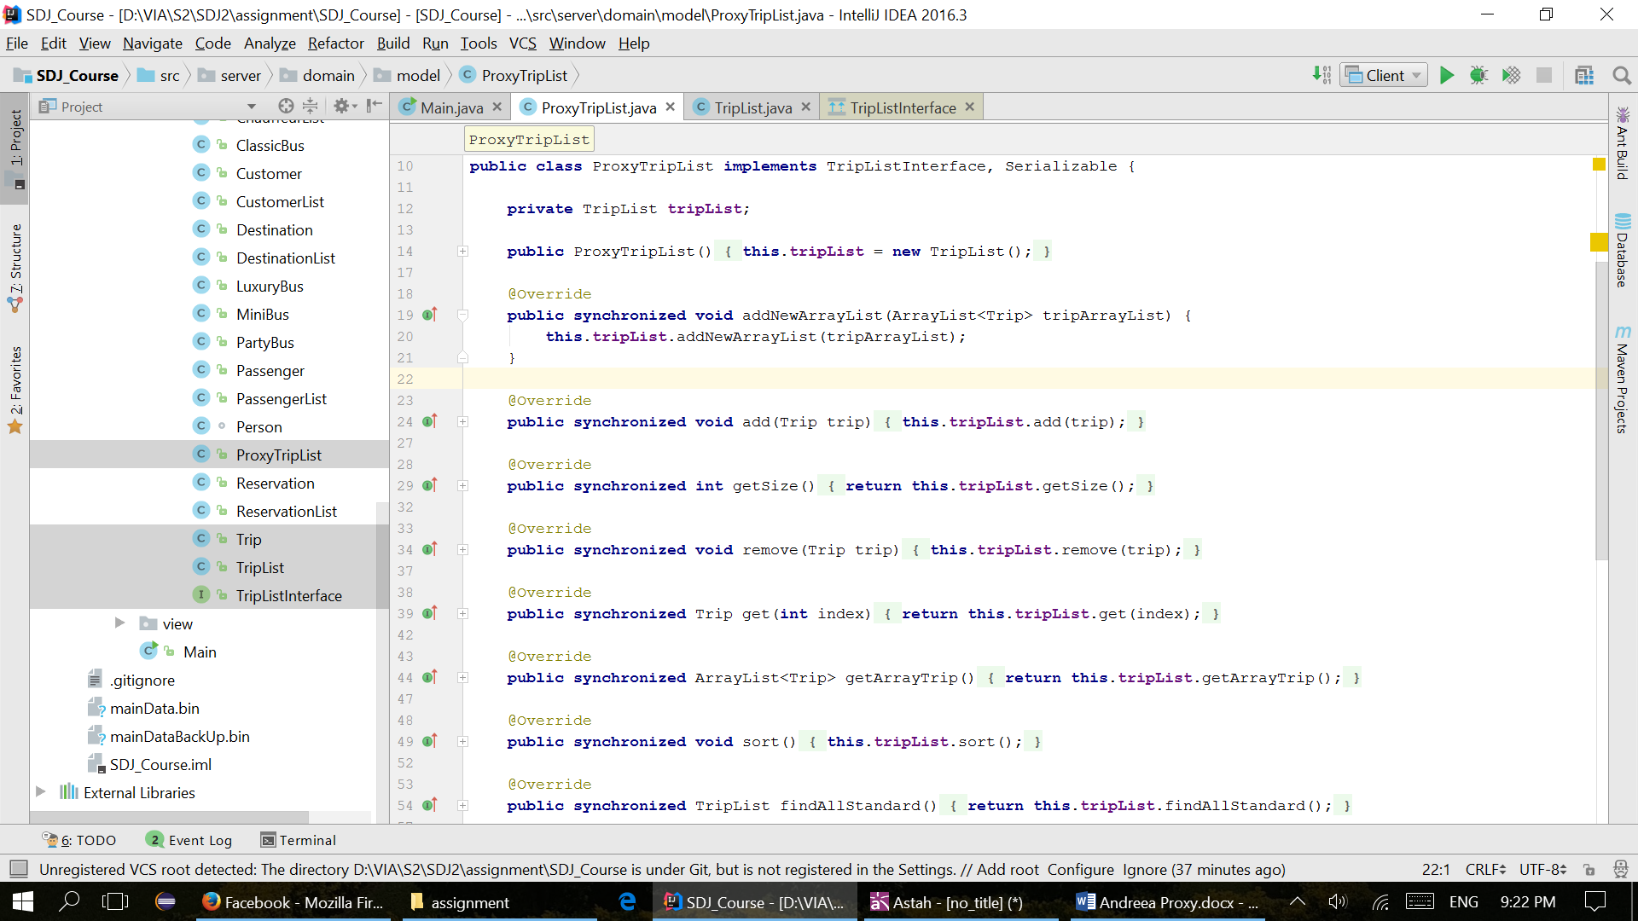

* 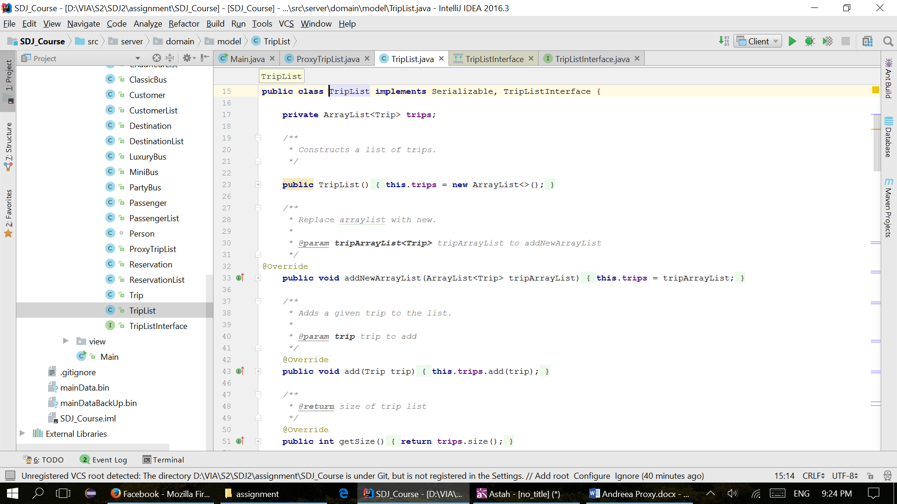real class